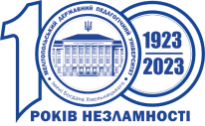


MINISTRY OF EDUCATION AND SCIENCE OF UKRAINE
BOGDAN KHMELNITSKY MELITOPOL STATE PEDAGOGICAL UNIVERSITY
CERTIFICATE
of conference participant
Velykyi Roman
IV International Scientific and Practical Conference
"Strategic priorities of the development of socio-economic systems in the context of the modern scientific measuring"
Improvement of professional skill - 0.8 ECTS credits
_{Rector} Natalia FALKO
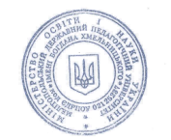
October 23, 2025 Zaporozhzhia

